PROJECT 2 DESIGN A HTML WEBPAGE GITHUB
DISCLAIMER:
IF The following assignment appears late/uncompleted I apologize in advance. At times my word tends to save drafted version instead of the finished product. Thank you

LINK TO GITHUB https://github.com/075Idiaz/Project2.HTML..git
STEP 1
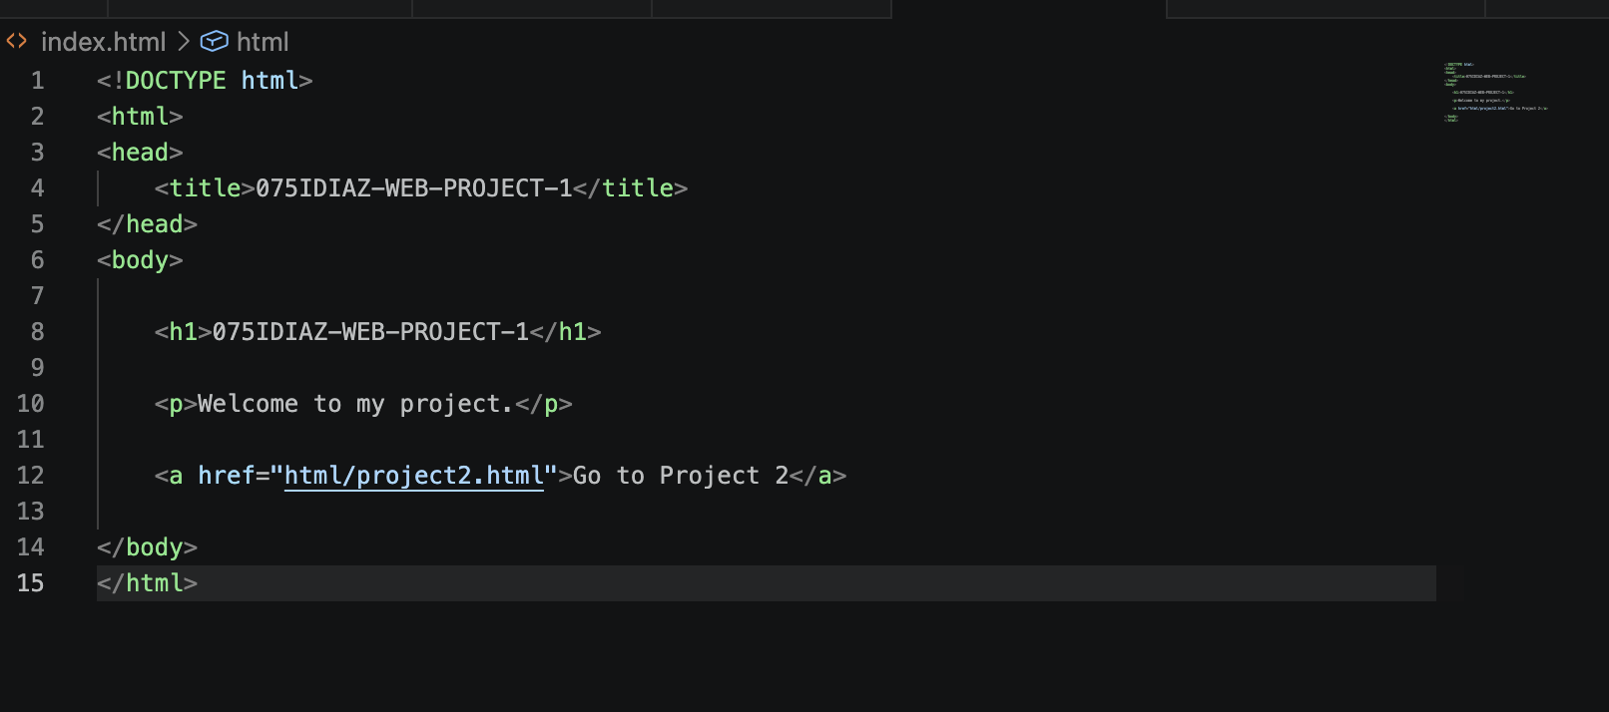
STEP 2, 3, AND 4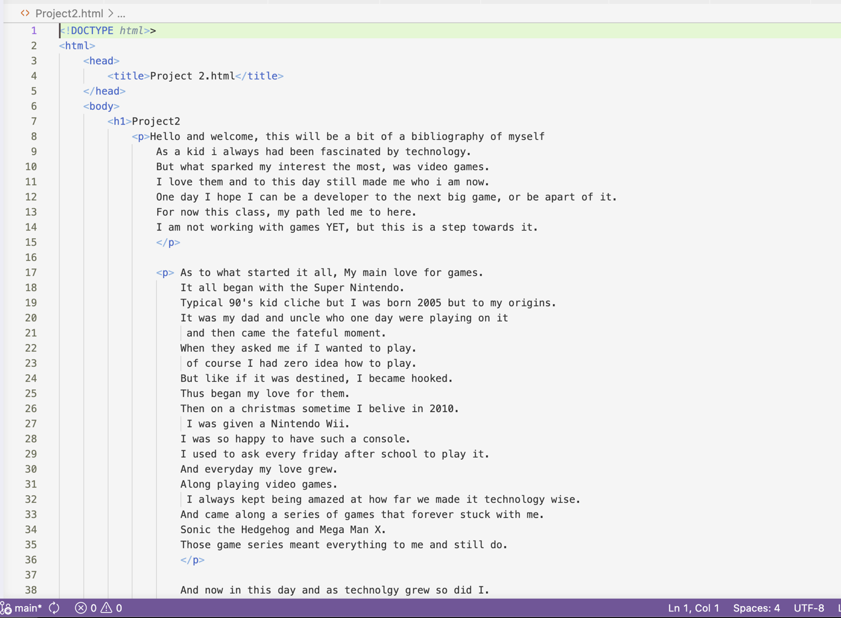
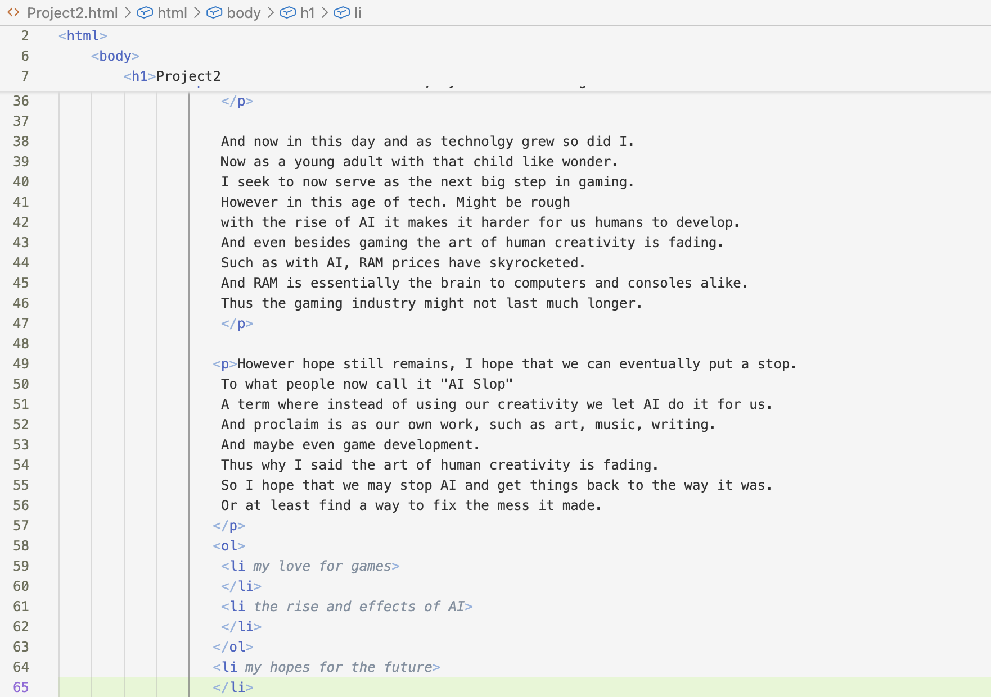

STEP 5 AND 6
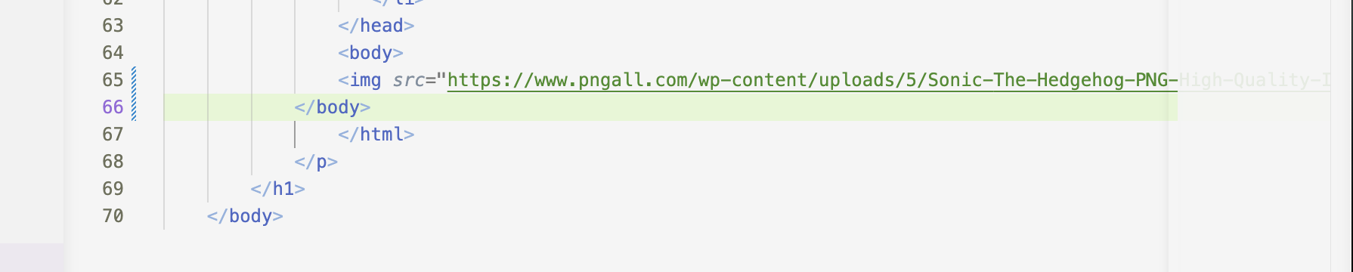
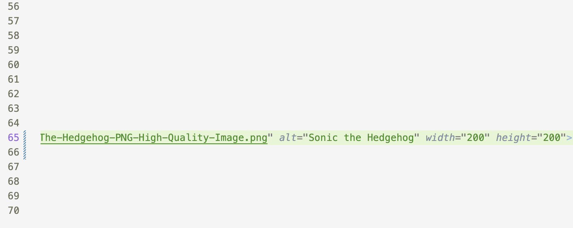

If in case the following image does not show VIA VSCode then here is the screenshot of the downloaded image from Uplash 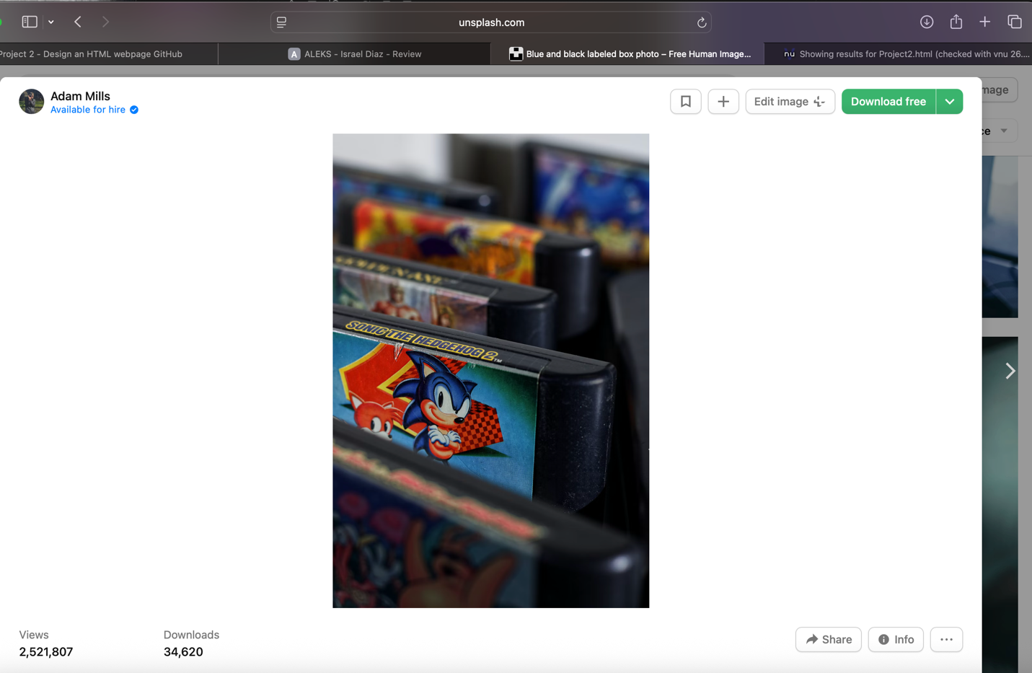

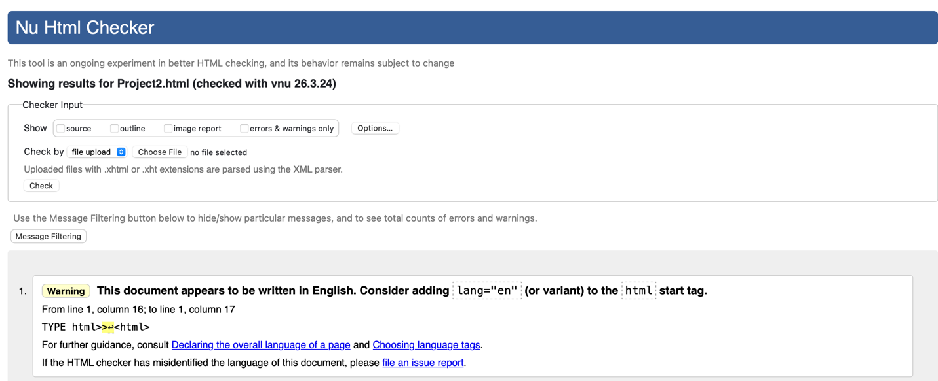

STEP 7, 8, 9, AND 10
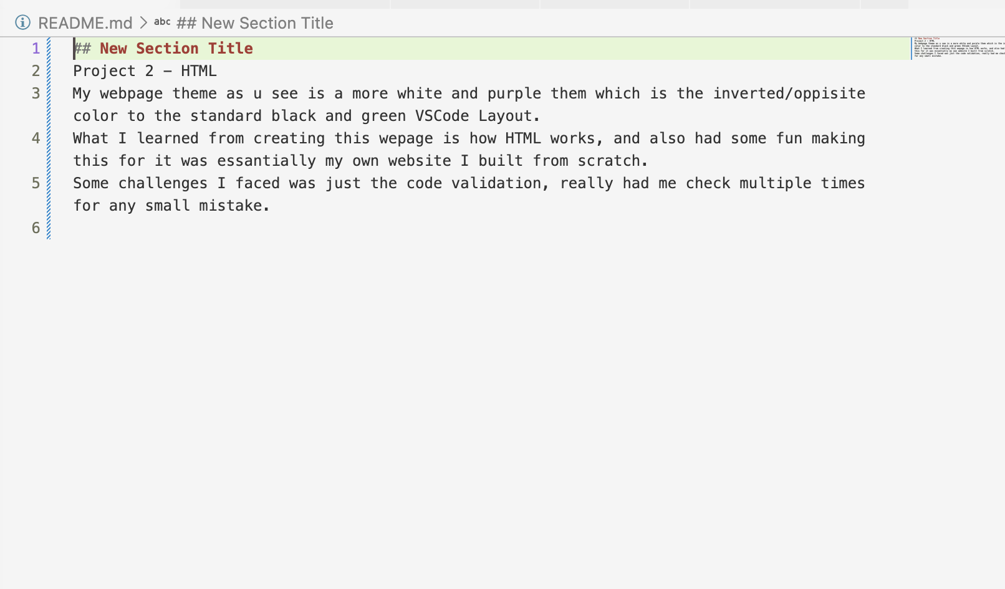
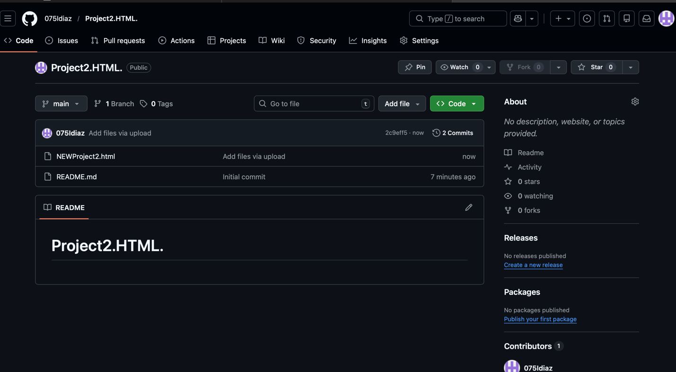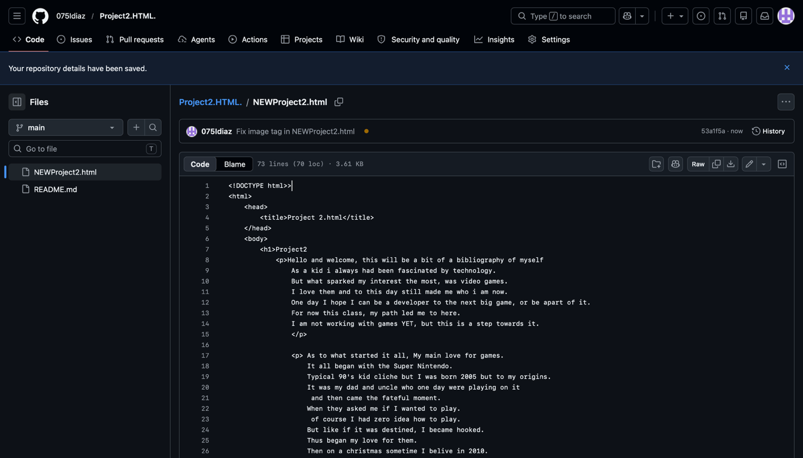
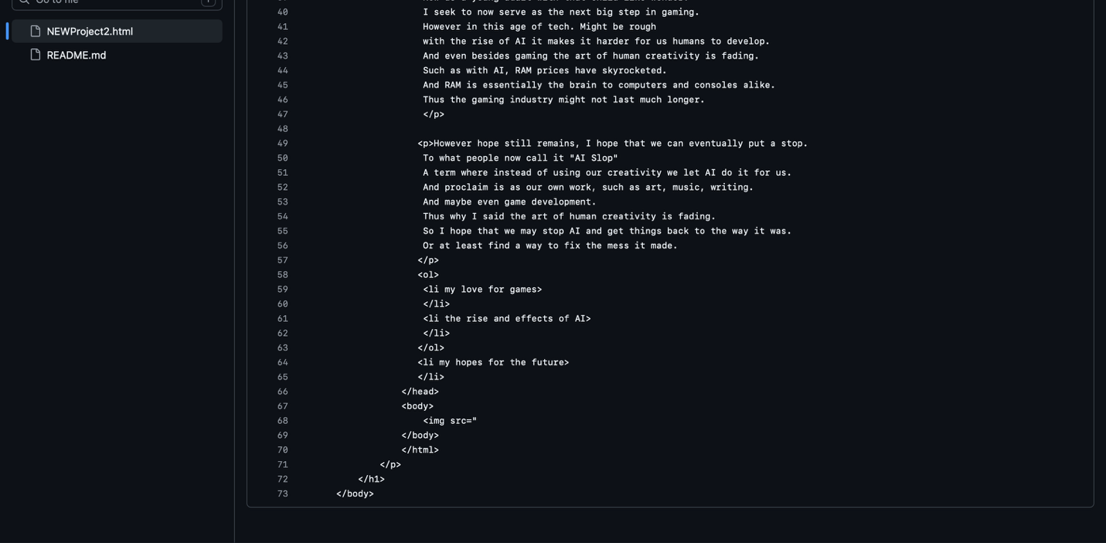
LINK TO GITHUB https://github.com/075Idiaz/Project2.HTML..git

